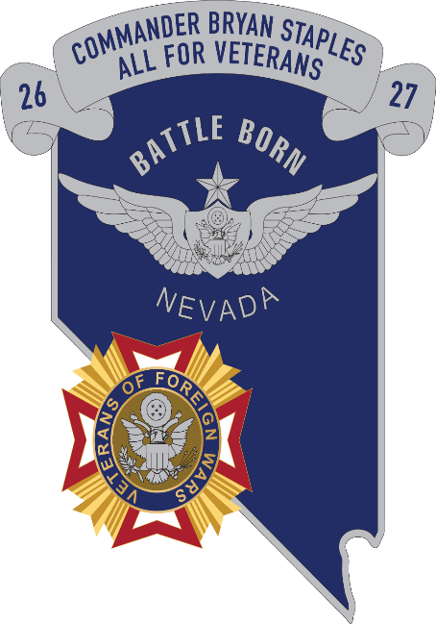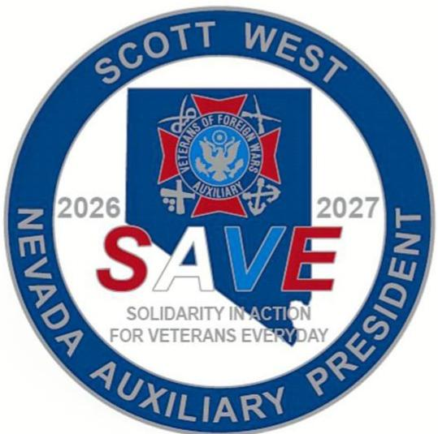
VFW AND AUXILIARY DEPARTMENT
OF NEVADA HOMECOMING
Commander Bryan Staples &
Auxiliary President Scott West

DATE: September 12, 2026 WHERE: Post 2350, Elko, Nevada

TIME: Doors Open: 2:00 pm DINNER: 5:00 p.m. – 6:00 pm

GIFTS: After Dinner FOOD: BBQ Chicken or Steak, Fixings, Drinks

PRICE: $30.00 per Person RSVP: Your Name(s) & Choice of Chicken or
Steak
Let Gil know if there are any special meal requests!!!
PRE-REGISTER BY: AUGUST 29. 2026

Name | Indicate  VFW or Aux # | Steak | Chicken | Total Paid
$30.00 each
Total Enclosed

Make Checks Payable to: VFW Post 2350
Mail to: Gil Hernandez
c/o VFW Post 2350
1316 7th St, Elko NV 89803-3250
Attn: Homecoming

Best Western Inn, 775-738-8787, 1930 Idaho St, Elko NV
Travelodge by Wyndham, 775-299-3582, 1785 Idaho St, Elko NV
Ramada by Wyndham (Stockmen’s). 775-738-5141, 340 Commercial St, Elko NV
Gold Country Inn and Casino by Red Lion Hotels & RV Park, 775- 738-8421, 2050 Idaho St, Elko NV
Maverick Hotel & Casino (was Red Lion), 775-738-2111, 2065 Idaho St, Elko NV
Iron Horse RV Resort, 800-782-3556, 775-777-1919, 3400 East Idaho St, Elko NV
or Look Up: Elko NV Hotels

